Energy Lab 7.1

Lab 7.1 perform a heating curve and note the phase changes

Heating Curve Worksheet 7.1
Ice is placed into a beaker. The temperature is measured over time as heat is added. The data is graphed below.

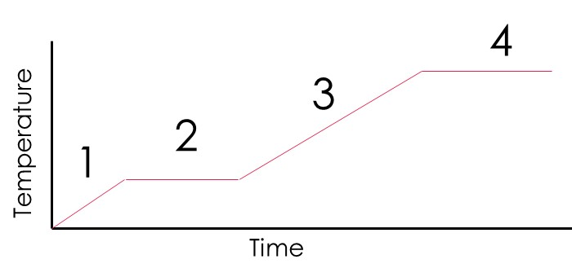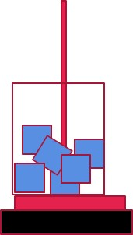
- What does the energy do in section 1 of the graph?

- What phases of matter exist in section 1 of the graph?

- What does the energy do in section 2 of the graph?

- What phases of matter exist in section 2 of the graph?

- What does the energy do in section 3 of the graph?

- What phases of matter exist in section 3 of the graph?

- What does the energy do in section 4 of the graph?

- What phases of matter exist in section 4 of the graph?

- What does the energy do in section 5 of the graph?

Phase Diagram Worksheet 7.2

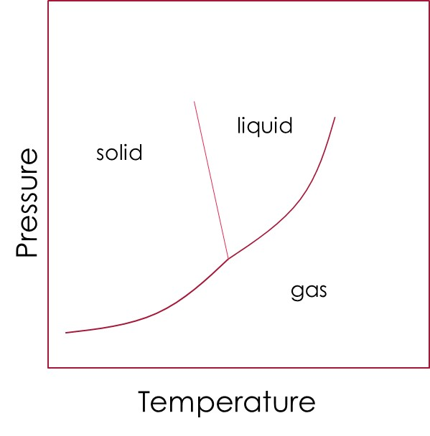
- Identify the phase change of the following
Starting phase Ending phase
- Freeze

- Evaporate

- Melt

- Sublimation

- Condensation

- Deposition

- Define and locate on the graph above

- Triple point

- Critical point

Super cooled solution Lab 7.2

Calorimetry Worksheet 7.3
Q = m * c * ∆T c for water is 4.18 J/g C or 1 cal./g C
Define in the equation above
Q -
m -
c -
∆T -
Answer the questions using the equation above and show your work
- How much energy in Joules is needed to change the temperature of 100.0 g of water by 10.0 C?

- How many grams of water can be heated from 20.0 C to 50.0 C using 12000.0 Joules?

- What is the final temperature after 800.0 Joules is absorbed by 15.0 g of water at 25 C?

- How much energy in cal. is needed to change the temperature of 50.0 grams of water by 60.0 C?

- The c for aluminum is 0.900 J/g C. How much energy is needed to raise the temperature of a 952 g block of aluminum from 20.0 C to 28.5 C?

Difficult:
- A piece of metal weighing 60.5 g was heated to 100 C then put into 100.0 mL of water (at 25.0 C initially). The metal and water equilibrate (reach the same temperature) at 28.2 C. Assuming no heat is lost, calculate c for the metal. (Hint: do the equation 2 times. Once for the water and use that Q for the block)

Calorimetry Lab Lab 7.3

Endothermic and Exothermic Worksheet 7.3
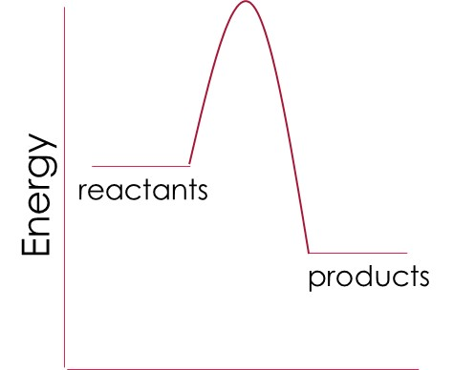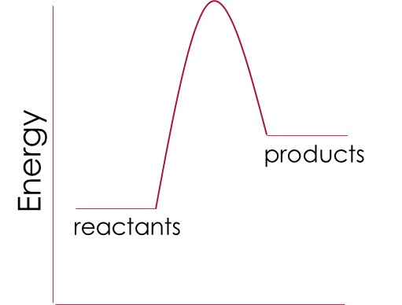
Figure 1 Figure 2

- Identify Figure 1 and 2 as endothermic or exothermic and explain why

- Figure 1:

- Figure 2:

- Define activation energy and draw them on the 2 graphs

- Are the following reactions endothermic or exothermic

- Acid and base are mixed and heat is released

- Combustion reaction (fire)

- An instant cold pack from the first aid kit

