Models of the Atom – Discussion Worksheet 1
Biology uses large molecules (bigger than we get in chemistry) and physics usually deals with forces and energy. Chemistry is the study of matter. We will start with as small as it gets (well for chemists anyways). Atoms make up everything. They the building blocks of everything.
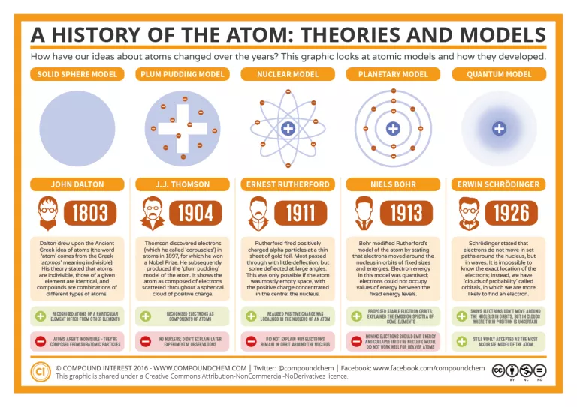
Image Source (can you still recognize the models even though someone else drew them?)
https://www.compoundchem.com/2016/10/13/atomicmodels/
These people were considered great scientists and they still got things wrong. The scientific method allows us to make a model, experiment and then change the model as needed. Each person was right with the information they had at the time, we just learned more and adapted the model. Discuss:
- Which model is the simplest?
- Contrast the first 2 models, what changed and why?
- Contrast the second and third models, what changed and why?
- Which models have electrons?
- Which models have a nucleus?
- Which is more important in the Bohr model, protons or electrons?
- Though the quantum model is still used, in 1932 the neutron was discovered. This is a neutral particle that is in the nucleus with the protons. Why didn’t this affect the model?
- Do you think the model can be further adapted to changes and what might they be?
Atom Basics Worksheet 1.2
What you need to know:
- Protons are positive
- Neutrons are neutral
- Electrons are negative
- All H elements have 1 proton, all He elements have 2 protons, etc… (see periodic table)
- In a neutral atom (no charge), the number of electrons = number of protons
- When written on the page, $\frac{4}{2}$He for example, the bottom number (atomic number) is the number of protons, the top number (atomic mass) is the number of protons + neutrons.
- The number of neutrons is dependent on the mass of the atom for example: $\frac{1}{1}$H has 1 proton and the mass is 1 so there is no neutron. Where $\frac{2}{1}$H has 1 proton and the mass is 2 so there is 1 neutron. These are called isotopes (same element, different number of neutrons)
The Bohr model of the atom works very well for atoms with small masses (usually less starts falling apart around element 21). So we will use it to learn the basics. Only a certain number of electrons can go in each ring, the first can hold 2, the second 8, the third 18.
- Where do the protons go in the model?
- Where do the neutrons go in the model?
- Where do the electrons go in the model?
- Draw a $\frac{1}{1}$H Bohr model
- Draw a $\frac{2}{1}$H Bohr model and how does it differ from $\frac{1}{1}$H

- How many protons, neutrons, and electrons are in: $\frac{4}{2}$He

- How many protons, neutrons, and electrons are in: $\frac{9}{4}$Be

- How many protons, neutrons, and electrons are in: $\frac{19}{9}$F

- How many protons, neutrons, and electrons are in: $\frac{24}{12}$Mg

- How many protons, neutrons, and electrons are in: $\frac{20}{10}$Ne

- How many protons, neutrons, and electrons are in: $\frac{35}{17}$Cl

- How many protons, neutrons, and electrons are in: $\frac{40}{20}$Ca

Bohr Models Lab 1.1 (remember labs are for a grade)

Materials:
One color of bead for each Protons #________
One color of bead for each Neutrons #________
One color of bead for each Electrons #________
Pipe Cleaner
Fishing line
Periodic Table of Elements
Scissors
Activity Sheet

Background Information:
Atoms are composed of protons (+), neutrons (0), and electrons (-). The core is the nucleus, which consists of protons and neutrons. Most of the mass of an atom (about 99.9%) is in the nucleus. Electrons occupy cloud configurations at several distinct distances from the nucleus, called energy levels. See chart below:
Energy Level | Electron Capacity
1 | 2
2 | 8
3 | 18
4 | 32

Procedure: Atomic Structure (read all instructions before beginning)
- As a group make one of the following atoms (usually assigned): atomic number 13-17 Al-Ar
- Use fishing line (use a long line) and string the correct number of protons and neutrons (yes I count them) for your assigned atom
- Tie it off and then ball it up and tie it so it stays somewhat in a ball leaving one long end of the fishing line free
- Use pipe cleaner for each energy level with the appropriate number of electrons
- Use the long fishing line to tie off your energy levels. At the end, I should be able to hold up your line and see a Bohr model of the atom you were making.

Application:
Fill in the blanks for the atom you built:
Name of Element_________________
Symbol___________
Atomic Number__________________
Mass #___________
Number of Electrons______________
Number of Protons________________
Number of Neutrons _______________

Classify the three subatomic particles according to charge, and location in the atom.

Charge Location
Proton
Neutron
Electron

What is an isotope?
_______________________________________________________________________________________________________________________________________________________________________________________________________________________________________________________________

Think of an isotope of lithium with a mass number of 8. Draw the Bohr model of lithium mass number 8 and then tell me how this differs from the isotope of lithium with a mass number of 7.

Lewis Dot Worksheet 1.3
Put the number of electron in outer shell around the symbol (Draw Bohr model if you need to)
electrons in each shell: 2, 8, 18, 32
Number of Protons Electrons Electrons in outer shell Draw Lewis dot
H
He
Li
Be
B
C
N
O
F
Ne
Al
P
S
Cl
Na
Ar
Ca
Blank Periodic Table Worksheet 1.4

Instructions:
- At the top of each block put the atomic number in each block
- In the middle of each block put the symbol in each block (do not put name unless you want it)
- At the bottom of each block put the mass number in each block
- Color or label the elements as metal, nonmetal, and metalloid (make sure you include a key)
- Color or label the elements with family names (make sure you include a key)

From this table you should be able to
- Atomic number for each element
- Symbol for each element
- Atomic mass for each element
- Tell if an element is metal, non-metal, or metalloid
- Give the family name for each element if it has one
- Identify the period for each element

I have been known to let you use this table on some tests, so you might want to make sure you can do the things I suggested above.

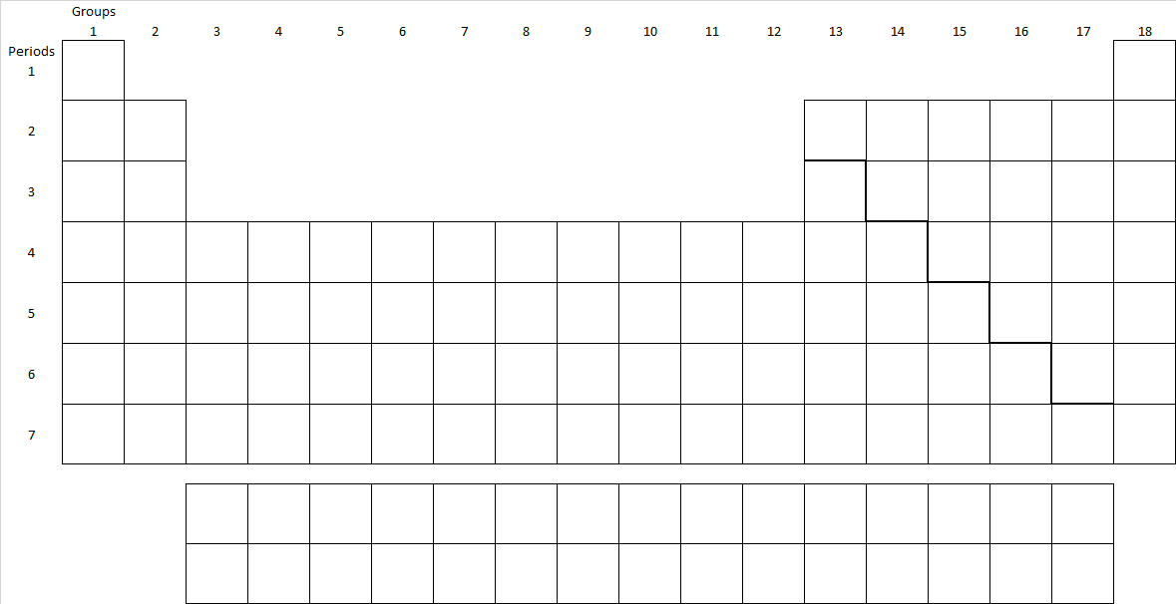
Periodic Table Arrangement Worksheet 1.5
The periodic table is your cheat sheet for the class, know how to use it.
Identify each element as a Metal (M), Non-metal (NM), or Metalloid (ML)
_____1. Ti _____2. U ____3. Br ______4. Si
_____5. O _____6. Ar ____ 7. Li ______8. Ca

Families: Alkali Metal (AK), Alkaline Earth Metal (AEM), Halogen (H), Noble Gas (NG), Transition Metal (TM), Lanthanide Series (L), or Actinide Series (A)
_____9. Ti _____10. U ____11. Br ______12. Si
_____13. Eu _____14. Ar ____ 15. Li ______16. Ca

Both Identify each element as a Metal, Non-metal, or Metalloid and give Families (if they have one)
_____17. Ba _____18. C ____18. O ______19. N
_____20. S _____21. Li ____ 22. P

Trends
23. Sort the following: Cl, Na, Fr
____>______>____ by electronegativity (tendency of atom to attract a shared pair of electrons)
____>______>____ by electron affinity (amount of energy released or spent when electron is added)
____>______>____ by ionization energy (amount of energy required to remove an electron)
____>______>____ by atomic radius (size of the atoms)

24. Sort the following: F, Be, Rb
____>______>____ by electronegativity (tendency of atom to attract a shared pair of electrons)
____>______>____ by electron affinity (amount of energy released or spent when electron is added)
____>______>____ by ionization energy (amount of energy required to remove an electron)
____>______>____ by atomic radius (size of the atoms)

