Graphical Representations Worksheet 3.1
There is no real lesson for this as we’ve already covered most of this topic
- Draw a ball and stick model of H₂O

- Draw a Lewis dot of H₂O

- Draw sodium atom with a positive charge

- Draw chlorine atoms with negative charge

- Draw sodium and chlorine atoms with their respective charge

What we haven’t covered
Spaced filled model – the ball and stick model doesn’t represent how much space the atoms actually take up. Notice the Cl is much larger than the H and you can’t see how they connect, they overlap.
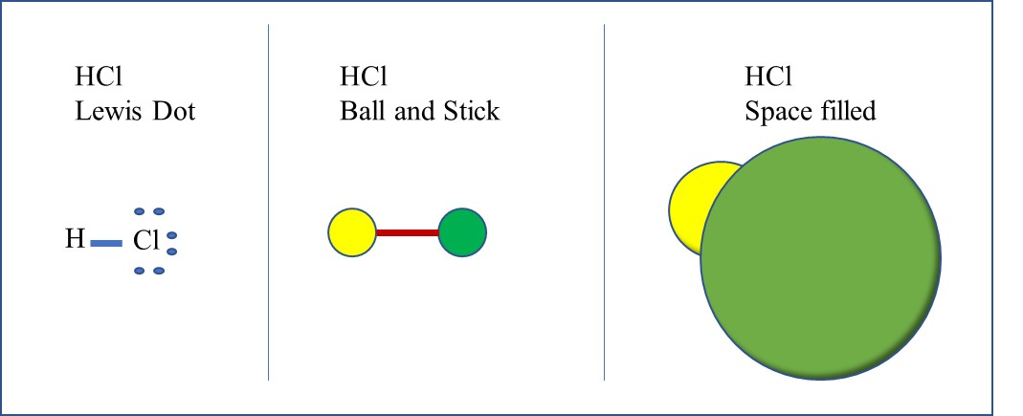
- Draw a space filled model of H₂O

Intermolecular Forces Worksheet 3.2
Give the strongest intermolecular force (hydrogen bonding, dipole-dipole, or London Dispersion) for each of the following (expect to draw the Lewis diagram if you get it wrong):
- Water ___________________________________________________

- CO₂ ___________________________________________________

- Nitrogen ___________________________________________________

- Acetone (CH₂O) ___________________________________________________

- O₂ ___________________________________________________

- BH₃ ___________________________________________________

- CO ___________________________________________________

- Ammonia (NH₃) ___________________________________________________

- CH₄ ___________________________________________________

- CH₃Cl ___________________________________________________

- HCl___________________________________________________

- HBr___________________________________________________

- HF ___________________________________________________

- Ammonium (NH₄⁺) ___________________________________________________

- Phosphorus trichloride ___________________________________________________

Intermolecular Forces Worksheet 3.3
Name all the intermolecular forces from strongest to weakest that occur in each of the following
- H₂ ___________________________________________________

- O₂ ___________________________________________________

- Nitrogen ___________________________________________________

- Acetone (CH₂O) ___________________________________________________

- CO ___________________________________________________

- Ammonia (NH₃) ___________________________________________________

- CH₄ ___________________________________________________

- CH₃Cl ___________________________________________________

- HCl___________________________________________________

- HF___________________________________________________

- Phosphorus trichloride ___________________________________________________

- CH₃OH___________________________________________________
Draw the Lewis dot number 12 and show different sections that can have each intermolecular force

Intermolecular Forces Lab 3.1
Materials:
Water
Isopropyl alcohol
Penny
Dropper
Procedure:
Water
- Use the dropper to place as many drops of water on the penny as you can before it falls off
- Record the results
- Repeat this experiment 2 more times
Isopropyl alcohol
- Use the dropper to place as many drops of alcohol on the penny as you can before it falls off
- Record the results
- Repeat this experiment 2 more times
Data:
Trial | Water | Alcohol
1
2
3

Questions:
- Which substance has stronger intermolecular forces and why based on your data?

- What intermolecular forces are present in each substance?

- Draw the Lewis dot diagram for each molecule to support your answer on number 2.

- Do you think C8H18 would have more or less drops before falling off the penny and why?1

